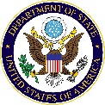
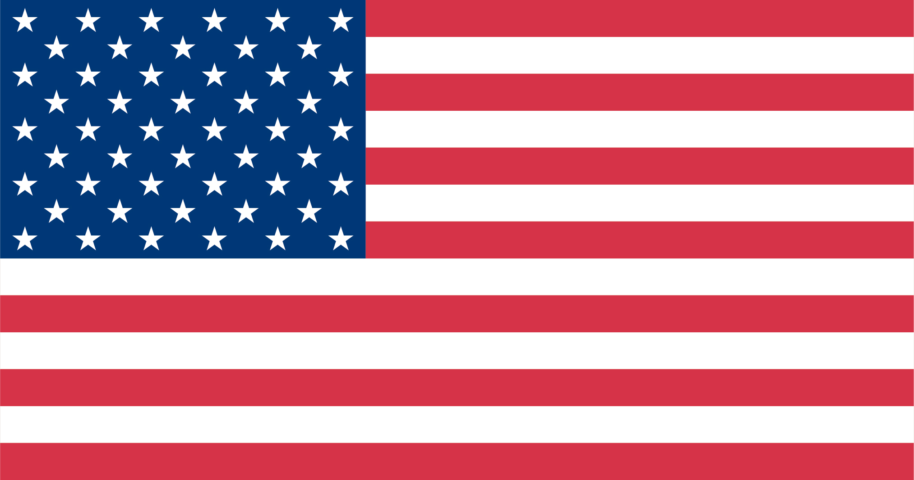
Community College Initiative (CCI) Program

Scholarship awards for the 2021-2022 Community College Initiative (CCI) Program
are contingent on the appropriation of Federal funding by the United States Congress.

Program Overview
The Community College Initiative (CCI) Program seeks to foster mutual understanding between the citizens of the United States and the citizens of participating CCI countries. Since the program’s inception in 2007, more than 3,400 participants from 21 countries have received scholarships for study at community colleges throughout the United States. The CCI Program is a program of the U.S. Department of State.

The CCI Program encourages a holistic learning and exchange experience and focuses on five program pillars: academics, cultural exchange, service learning, professional and career development, and leadership and action planning. All pillars of the CCI Program are of equal importance. The program provides participants with a non-degree, academic program at a U.S. community college designed to build participants’ technical skills in applied fields, enhance their leadership capabilities, and strengthen their English language proficiency. It also provides opportunities for professional internships, service learning, and community engagement. After completing the program, participants return home with enhanced skills to help them contribute to the economic development of their countries.

The CCI Program demonstrates U.S. commitment to increasing access to higher education for international students from underrepresented and underserved communities in selected countries and highlights the learning environment offered at U.S. community colleges. The program also builds U.S. community colleges’ efforts to deepen international education partnerships and programming.

Community colleges are predominantly publicly funded, inclusive institutions in local communities that welcome all who desire to learn, regardless of wealth, heritage, or previous academic experience. Community colleges offer individual courses (credit and non-credit), certificate programs, workforce development training, and associate degrees. Associate degree coursework at community colleges is roughly equivalent to that offered in the first two years of a four-year Bachelor’s degree program. There are more than 1,100 public, independent, and tribal community colleges across the United States. Community colleges are sometimes referred to as technical colleges or junior colleges.

Fields of Study Summary
The CCI Program offers study in the following fields:

- Agriculture
- Applied Engineering
- Business Management/Admin

- Early Childhood Education
- Information Technology (IT)
- Media

- Public Safety
- Tourism and Hospitality Management

The CCI Program offerings within these fields of study are limited to specific concentration areas listed on the 2021-2022 CCI fields of study summaries and included as part of this application.

Courses and programs of study vary by individual colleges. All colleges offer introductory classes that would be taken during the first two years of a four-year Bachelor’s degree. The CCI Program does not offer advanced field-specific courses. Participants will work with their Program Coordinators at each host college to develop an individual program plan within his/her field of study and concentration area. Participants should develop their goals broadly within these fields of study and concentration areas. In this application, participants should describe their specific areas of interest in their proposed fields of study and concentration areas, their related experience, and their long-term goals.
Participants are applying for the CCI Program and are not applying to a specific academic degree program at a particular institution. Based on their proficiency in English, participants will have access to courses at the CCI community college where they are placed. Participants may earn an academic certificate in their field of study or complete courses that are relevant to their professional goals. Certificate programs are not available for all programs at all campuses and are contingent upon multiple factors, including the participant’s level of English. Participants will combine academic or professional coursework with first-hand practical experiences through internships or service learning that will help them build their professional skills and capacities.

The educational system in the United States will be different from the educational systems in the participants’ home countries. To be successful in U.S. academic courses, participants will need to attend all classes, participate fully, complete assignments on time, and complete additional coursework (such as readings, essays, individual and group projects) during their own time outside of the classroom. It is common practice to have 6-10 hours of homework each week after each 3-hour class.

CCI Eligibility Requirements
Everyone who meets the CCI eligibility criteria listed below is welcome to apply regardless of race, color, national origin, sex, age, religion, geographic location, socio-economic status, disability (physical or mental), sexual orientation, or gender identity. Persons with disabilities are strongly encouraged to apply. Competition for the CCI Program is merit-based and open to anyone who:
- Is a citizen, national or permanent resident qualified to hold a valid passport issued by a country participating in the CCI Program.
- Is currently residing in the eligible country.
- Is 18 years or older by July 1, 2021.
- Has successfully earned a secondary school diploma.
- Has not completed the equivalent of three years toward a U.S. bachelor’s degree or higher in the field of study the applicant is nominated to pursue. Nominees without substantive post-secondary education will be given placement priority.
- Has demonstrated commitment to the selected field of study through some academic or professional experience. The program aims to identify participants with proven skills or interest and limited professional experience in the fields of study offered.
- Has basic working knowledge of English language as demonstrated by a minimum TOEFL score of 450. (Note: To enroll in credit-bearing courses in an academic field of study, the applicant must meet the minimum language requirements of the host college—usually 500 on the TOEFL test or equivalent scores on other standardized tests. English language training will be necessary and is available for those who do not demonstrate this level of proficiency. Participants with a score below 500 must have an interest in taking English language classes as a primary academic focus; they will have very limited access to courses in their field of study. All participants will be retested upon arrival at their host institutions. The host campus testing result will be the score used to determine course placements.)
- Has limited or no overseas study experience. Nominees with no prior overseas study or travel to the United States will be given placement priority.
- Meets any customized requirements of the home country Embassy/Consulate or Commission.
- Submits a complete original application.
- Is able to receive a U.S. J-1 visa and meet the program conditions to maintain that status.
- Is willing and physically able (with accommodations as required) to complete the program in its entirety, including activities or travel that may be programmed on any day of the week, possibly including early morning or evening hours.
- Is committed to returning to his/her home country after completion of the program and satisfying the J-visa two-year residency requirement.
- Is able to begin the academic exchange program in the United States in July 2021.
Ineligibility
Individuals in the following circumstances are NOT eligible for the Community College Initiative Program:
- U.S. citizens.
- Non-U.S. citizens living in the United States.
- Individuals currently participating in academic, training, or research programs in the United States.
- Individuals currently studying, residing, or working outside of the eligible countries.
- Individuals who have participated in an exchange visitor program sponsored or funded by the U.S. government for a period of more than six weeks and who have not fulfilled their two-year home residency requirement by the time of their CCI application.
- Individuals who have applied for U.S. permanent residency.
- Local employees of the U.S. missions abroad who work for the U.S. Department of State and/or the U.S. Agency for International Development (USAID). Employees are also ineligible for one year following the termination of employment.
- Immediate family members (i.e., spouses and children) of U.S. Embassy and Fulbright Commission employees. Family members are also ineligible for one year following the termination of employment.
- Persons arrested for, charged with, or convicted of a crime (excluding minor traffic violations).

Application Review Process and Criteria
The CCI Program is conducted as a merit-based open competition. After the application deadline, all applications will be reviewed in country for eligibility and assessed by a panel of exchange program specialists. Competitive applicants will be interviewed in their home countries by a nomination committee. All applicants will be notified of their nomination and placement statuses on a rolling basis from spring to summer 2021.

The nomination committee will use the following criteria to evaluate applications (not in order of importance):
- Demonstrated interest and professional goals in the field of study applicant wishes to pursue.
- Cross-cultural interest.
- Leadership potential.
- Flexibility and suitability as an exchange student.
- Proficiency in written and spoken English.
- Physical ability and willingness to complete the program in its entirety, including activities or travel that may be programmed on any day of the week and during early morning or evening hours.
- Commitment to returning to home country after the program to fulfill a two-year home residency requirement.
- Preference will be given to applicants who have no prior experience outside their home countries.
- Preference will be given to applicants who represent underserved and underrepresented communities, including women.
- Preference will be given to those applicants who have completed secondary school and have not yet earned a degree equivalent to a U.S. bachelor’s degree or higher.
- Preference will be given to those applicants who can express how the CCI Program connects directly to their personal and professional short-term and long-term goals.

General Application Instructions
- Submit a completed original application with signature on the last page.
- Each applicant must complete his/her own application form. Applicants may consult with others for advice on how to complete the form, but each applicant must write his/her own responses.
- Please answer ALL questions on the application in English. Do NOT leave a space blank. If a question does not apply to you, enter N/A (not applicable).
- Include your full legal name with family name (surname) in CAPITAL LETTERS first as spelled on your international passport (if available).
- Include complete contact information, including postal codes for all addresses and city/country codes for all phone numbers.
- Handwritten applications must be neatly printed.
- Submit the application by the deadline established by the U.S. Embassy or Fulbright Commission located in your country.

Financial Provisions of the Grant
- J-1 visa support.
- Round-trip travel from participant’s home city to host institution in the United States.
- Tuition and mandatory college fees.
- Housing and meals.
- Small allowance for books, materials, and incidental expenses.
- Limited Accident and Sickness coverage that is J-visa compliant.
- A variety of personal and professional development activities.

Learn More: CCI Program Information and Social Media Sites

CCI Website: www.nvcc.edu/ccip
CCI Blog: https://blogs.nvcc.edu/cci/
CCI YouTube: www.youtube.com/cciprogram
CCI Facebook: www.facebook.com/cciprogram
CCI Twitter: www.twitter.com/cciprogram
CCI Instagram: www.instagram.com/cciprogram

