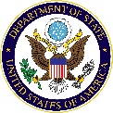
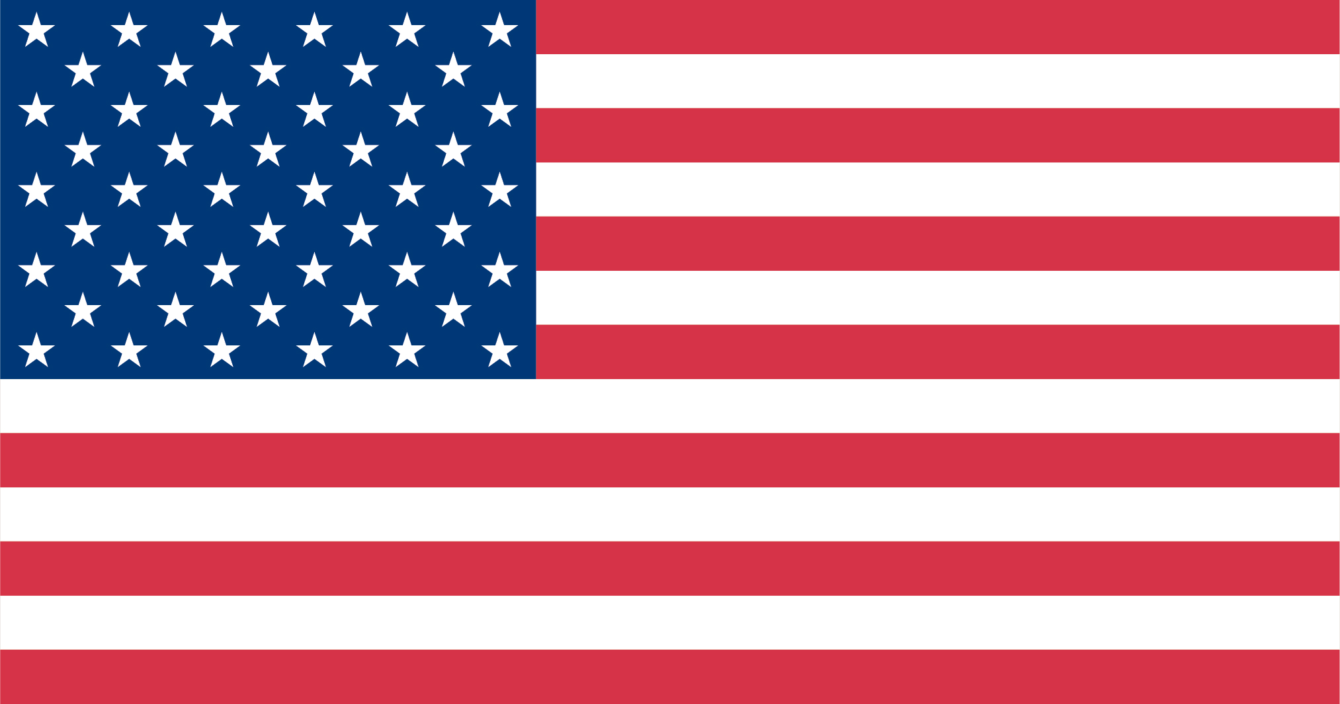

Community College Initiative Program

Student Application 2025 – 2026

Personal Information
Name of applicant as indicated on passport if passport is already issued. Please type or print.

______________________________ _________________________ ________________________________
SURNAME/FAMILY NAME First/Given Name Middle Name(s)
(write in all capital letters)
Home Address:  Street and number:  City:  State/province:  Postal code:  Country: |  |  | Home Phone:
 |  |  | Mobile Phone:
 |  |  | E-mail:
 |  |  | Location where you currently live:
 |  |  | ☐ Federal Capital  ☐ Other City/Town | ☐ Major City  ☐ Rural Area
Gender:  ☐ Male  ☐ Female  ☐ Non-binary  ☐ Intersex  ☐ Gender Non-conforming | Marital status:  ☐ Single  ☐ Married | Do you have a passport?  ☐ Yes  ☐ No | Date of birth (month/day/year):  Month of birth:  Day of birth:  Year of birth:
Country/Countries of citizenship:  Country/Countries of permanent residence: |  |  | Place of birth (city or town and country, as listed in passport, if available):  City of birth:  Country:
Are you currently a student? ☐ Yes ☐ No  If yes, I am currently a…  ☐ Secondary School/High School Student  ☐ Undergraduate Student  ☐ Other:  Name of college/institution enrolled:  I am currently studying ☐ Full-time ☐ Part-time  I am enrolled in a degree program. ☐ Yes ☐ No |  |  | What is the highest educational degree you have completed?  ☐ Secondary School/High School  ☐ Postsecondary Study  Number of years of study completed: __________  ☐ Other: _____________________  Number of years of study completed: __________
Have you participated in any U.S. government exchange program? Yes ☐ No ☐

If yes, give name of the program:

Duration of the program: Year you participated:

Your proposed Field of Study during the Community College Initiative Program:

Applicants must apply in only one (1) field of study and preferred concentration area from the options below. Subfield concentration areas and availability of academic certificates are contingent upon host college availability.

Field of Study:  (check only one) | Subfield/ Concentration Area:  (check only one)
☐ Agriculture | ☐ Agribusiness and Production Management
 | ☐ Sustainable Agriculture
☐ Applied Engineering  Applicants will need to have a solid foundation in math and will need to take a math placement exam at their host campuses to gain access to credit-bearing courses. | ☐ Architecture and Construction Management
 | ☐ Automotive Technology
 | ☐ Electronics Technology
 | ☐ Manufacturing Technology
☐ Business and Entrepreneurship | ☐ Business Management
 | ☐ Entrepreneurship
 | ☐ Hospitality
 | ☐ Marketing and Public Relations
 | ☐ Supply Chain Management
☐ Early Childhood Education | ☐ Early Childhood Education and Development
 | ☐ Special Education
☐ Information Technology | ☐ Artificial Intelligence and Data Analytics
 | ☐ Computer Science and Programming
 | ☐ Cybersecurity
 | ☐ Networking and IT Support
☐ Creative Economy and Media | ☐ Digital Media and Film Production
 | ☐ Graphic Design
 | ☐ Web Design and Development

To pursue certificates in a field of study, you may be required to repeat entry-level courses previously completed to meet prerequisite requirements for the certificate. A certificate in the selected subfield is not guaranteed. Official copies of any post-secondary transcripts, course syllabi or other documentation of course content may be considered for evaluation if you have documented evidence of satisfying the prerequisite requirements. This process requires precise documentation, may be lengthy, and is not guaranteed. If you would like for your previous academic coursework to be evaluated and considered, you will need to bring official copies of your educational records with you to the United States for host campus evaluation.

Knowledge of Languages: Rate yourself Excellent, Good, Fair, or Poor. Include all languages that you speak or have studied, including English. List your native language first.
Language | Reading | Writing | Speaking | Listening

English Language Proficiency: If you have taken any standardized test of English language proficiency (for example TOEFL, IELTS, Duolingo) please list the test taken, give the results, and provide a copy of the test results.

Test Taken: : Date Taken: Results (also attach copy) :
Background Information
Educational History: Please list educational institutions that you are currently attending or have attended with the most recent listed first. Please attach a translated and certified copy of your transcripts for any institution from which you received a certificate, diploma, or degree.

Name of Institution/Location | Major Field of Study | Dates Attended (Month, Year)  From To |  | Actual Name of Degree or Diploma (Do not translate) | Type of Education  (Select one) | Date Degree Received / Anticipated Completion Date
Current or Most Recent Education: |  |  |  |  | ☐ High School  ☐ Postsecondary  ☐ Other:
Previous Education: |  |  |  |  | ☐ High School  ☐ Postsecondary  ☐ Other:  ________________

Work Experience: Are you currently employed? ☐ Yes, full-time ☐ Yes, part-time ☐ No

List jobs held, begin with current or most recent employment. (Continue on additional sheets of paper, if necessary)
Name and address of employer | Position held | Date  From:  (Month/  Year) | Date  To:  (Month/  Year) | Responsibilities
Current Position:

Professional and Volunteer Experience: In addition to jobs held, please list relevant professional non-paid, volunteer and/or leadership positions or experiences.
Position | Date  From:  (Month/  Year) | Date  To:  (Month/  Year) | Responsibilities

Are you currently employed or have you been employed in the previous 12 months for the U.S. Department of State and/or the U.S. Agency for International Development (USAID)? ☐ Yes ☐ No

Are you an immediate family member of someone who is currently employed or has been employed in the previous 12 months by the U.S. Department of State and/or the USAID? ☐ Yes ☐ No

If you have traveled or lived in any country other than your own, indicate the places where you traveled, the dates of that travel (month and year), and the purpose of the travel. (Continue on additional sheets of paper, if necessary)
Country | Dates of Travel | Purpose of Travel

Emergency Contact Information: Below, provide the names, addresses and telephone numbers of individuals to be notified in case of an emergency.
Name of individual | Location & address of individual | Indicate relationship to you (father, mother, friend, etc.) | Languages this person speaks
List contacts in your home country
Address:

Telephone:
Email:
Address:

Telephone:
Email:
List contacts in the United States, if any
Address:

Telephone:
Email:
Address:

Telephone:
Email:

Please list family members who have participated in a U.S. government-sponsored exchange program in the United States. (Continue on additional sheets of paper, if necessary)
Name of individual | Relationship | Name of program | Program dates

Please list any family members who are currently applying to participate in a 2025-2026 U.S. government-sponsored exchange program in the United States. (Continue on additional sheets of paper, if necessary)
Name of individual | Relationship | Name of program | Program dates

Please list any disabilities or special accommodations needed (mental and physical) and provide a detailed description of each. (Continue on additional sheets of paper, if necessary)
Disability or special accommodations | Description

Persons with a disability and/ or require special accommodations are strongly encouraged to apply. The application materials should provide as accurate, and as detailed, information as possible about any disability or special accommodations. That information will facilitate the candidate’s needs being fully understood during the final selection process and to be adequately met by potential U.S. host campuses, and is not a deciding factor of eligibility.

Free Response. Please type or write neatly on separate sheets of paper.
Please be open and candid in your responses. These essays should be written in your own words, and will help us understand a little more about who you are as a unique individual.

Response #1: Describe your related experience within your proposed field of study. How would this program of study build on your past education, training, and/or experience? If you are new to this field, why did you choose this field? Your response helps us match your interests with college programs.
(Your response should be a minimum of 300 words and a maximum of 800 words.)

Response #2: Why are you applying for the CCI Program? Describe the goals that you intend to accomplish during the CCI Program. Consider the five pillars of the CCI Program (academics, cultural exchange, service learning, internships, and leadership and community impact), and how they will integrate together to help you reach your goals in the short- and long-term.

(Your response should be a minimum of 200 words and a maximum of 700 words.)

Response #3: If you could make one change in your community, what would it be? What activities would you complete 6-12 months after returning home from the CCI Program to improve this community issue? Please be specific.
(Your response should be a minimum of 200 words and a maximum of 700 words.)

Response #4: The CCI Program is an intensive program with high expectations. Describe a challenging situation or a disappointment in your educational, professional, or personal life where you demonstrated resilience and perseverance. Describe how you approached the situation or disappointment and what you learned from it. Please be specific.
(Your response should be a minimum of 200 words and a maximum of 700 words.)

Response #5: Describe a time when you had to work with someone whose opinions/beliefs/views were different from your own. How did you demonstrate leadership and openness to manage the situation and overcome the conflict?
(Your response should be a minimum of 200 words and a maximum of 700 words.)

How did you learn about the CCI Program?
___U.S. Embassy or Fulbright Commission
___ College/University
___ Non-Government Organization (NGO)
___ CCI alumni
___ Family or friend
___ Social media post
___ Other

CCI Program Timeline

Oct 2024 2025-2026 CCI Program application launched in participating countries.
Oct 2024 – Feb 2025 Applications accepted and reviewed in each county. Interview committees invite semifinalist candidates for interviews.
Feb 2025 Embassies and Fulbright Commissions nominate slate of candidates to ECA for final selection and placement.
Mar 2025 Medical Forms due.
Apr 2025 ECA selects and places candidates. Only candidates with complete application files will be considered for placement.
Late Apr 2025 Placed and alternate candidates are announced and invited to pre-departure orientations.
Apr – Jul 2025 Additional candidates are placed if openings become available.
May – Jun 2025 Candidates participate in pre-departure orientations, review Terms and Conditions of the CCI Program and other program materials, and submit signed Terms and Conditions document.
May – Jun 2025 Candidates apply for visas and submit proof of visas to Embassy or Commission.
Candidates engage with host campus Program Coordinators and submit additional required documents for each host campus.
Late Jun – early Jul 2025 Candidates receive travel itinerary and travel information.
Mid-Jul 2025 Candidates travel to their host campuses and begin their CCI Programs!

Community College Initiative Program
Application Certification Statement

Certification: I certify that I completed this application myself, that the information given in this application is complete and accurate, and that I have carefully read and understand it. I also certify that I meet eligibility requirements.

I understand that program administrators reserve the right to verify all the information listed in the application. I understand that giving false or misleading information in the application will eliminate me from the competition or cause my dismissal from the Community College Initiative Program.

Also, I acknowledge that I am aware of the following program requirements:
- I must follow all program rules and regulations and observe all the laws of the United States during my stay there.
- At the end of the academic year program, I will return to my home country and fulfill a two-year, home country residency requirement in compliance with the terms of my J-visa. I understand that I may not extend my program dates.
- My spouse, children, other relatives or individuals are not permitted to accompany me to the United States on the program.

All applicants must submit the following documents for an application to be considered complete:
☐ Application Form: Applicants must provide complete information for all questions. Do not leave a question blank. If it does not apply to you, write “NA” for Not Applicable. Sign and date the application form.
☐ Essay Questions: Applicants must answer each question. Answers must be the applicant’s own work.
☐ Secondary School Diploma: A copy of the applicant’s secondary school diploma, with an English translation.
☐ Transcripts: A copy of applicant’s transcript for most recent year of study completed (high school or undergraduate). The transcript may be in the language of instruction, with an English translation.
☐ English Test Results, if available: Provide official English test score report.
☐ International Passport, if available: Provide a copy of your passport data page. If you do not have an international passport yet, it is highly recommended that you begin the process of applying for a passport (including obtaining any required local documents) as it may take a significant amount of time to receive this document.
☐ Any country-specific requirements
☐ Medical History and Examination form

*Only candidates with complete applications will considered for selection and placement.*

_________________________________ ________________________________________
Signature of applicant Date (month/day/year)

